**Containerization and Dockers**

**1.What is containerization?**

Containerization is a lightweight form of virtualization that involves packaging an application and its dependencies into a single unit called a container. Unlike traditional virtualization, which requires an entire operating system for each instance, containers share the host OS kernel while running isolated processes. This allows for:

* **Portability**: Containers can run consistently across different environments, whether on a developer's laptop, a testing server, or a production cloud platform.
* **Scalability**: Applications can be easily scaled by creating multiple container instances to handle increased load.
* **Efficiency**: Containers use fewer resources than virtual machines, allowing for quicker startup times and better utilization of system resources.
* **Simplified Deployment**: With everything bundled together, deploying applications becomes faster and more predictable.

**2.What is docker?**

Containerization is the technology, and Docker is platform which implements containerization.

**3.Docker installation in ubuntu VM:**

root@Ubunutu:/home/vboxuser/Desktop/Devops/Docker-Zero-to-Hero# history

1 apt-get install ca-certificates curl

2 install -m 0755 -d /etc/apt/keyrings

3 curl -fsSL https://download.docker.com/linux/ubuntu/gpg -o /etc/apt/keyrings/docker.asc

4 chmod a+r /etc/apt/keyrings/docker.asc

5 echo "deb [arch=$(dpkg --print-architecture) signed-by=/etc/apt/keyrings/docker.asc] https://download.docker.com/linux/ubuntu \

6 $(. /etc/os-release && echo "$VERSION_CODENAME") stable" | sudo tee /etc/apt/sources.list.d/docker.list > /dev/null

7 sudo apt-get update

8 sudo apt-get install docker-ce docker-ce-cli containerd.io docker-buildx-plugin docker-compose-plugin

9 sudo docker run hello-world

10 uname -m

11 curl -LO <https://storage.googleapis.com/minikube/releases/latest/minikube-linux-amd64>

**4.Docker installation verification:**

Execute docker run hello-world:

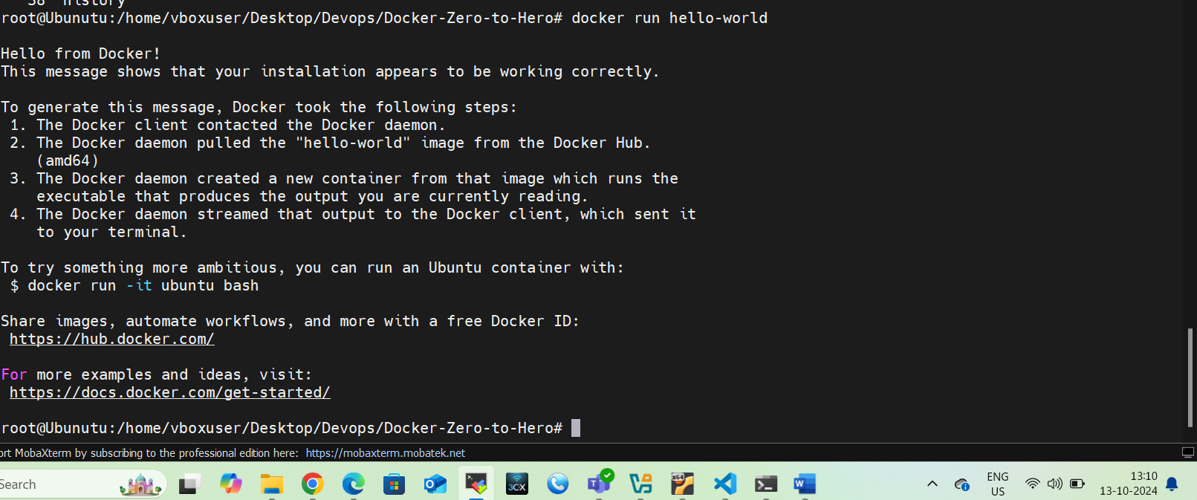

**5.Difference between Virtualization and Containerization:**

*For virtualization we need hypervisors like virtual box or vmware where as for containerization no hypervisors are required.

*In virtualization, there will be a guest operating system, but where as in containers, it will not have complete OS, it will only have application dependencies.

*Container are light weight than VM.